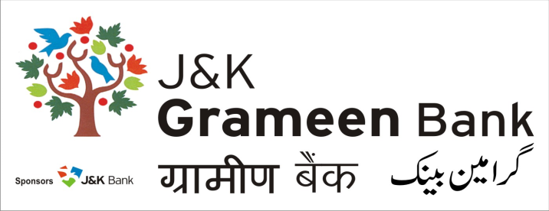
HUMAN RESOURCE DEVELOPMENT DEPARTMENT (HRDD) HEAD OFFICE NARWAL JAMMU
': 9797143008
E-mail: personnel.hoj@jkgb.in
NOTICE

Recruitment in J&K Grameen Bank is being done through Indian Banking Personnel Selection (IBPS) under IBPS RRB CWE. Recruitment Details are released almost every year on the website of IBPS i.e. www.ibps.in as well as on Bank’s website.

The recruitments are made through written test (Preliminary & Mains) and interview or through written test (Preliminary & Mains).

Candidates selected under IBPS are then allotted to J&K Grameen Bank for completion of various formalities before issuing appointment letters to candidates. IBPS do not issue appointment letter to candidates.

Candidates should check details of recruitments on website of IBPS i.e. www.ibps.in. In case of any doubt candidates may contact Human Resource Development Department, (HRDD) on email: personnel.hoj@jkgb.in / hod.hrdd@jkgb.in and Contact: 97971-43008.

The Roll Numbers of successful candidates of various recruitments should also be checked from Bank’s website.

Further, J&K Grameen Bank does not send any e-mail correspondence relating to employment from free web based email accounts such as Gmail, Ymail, Hotmail, Rediffmail and so on.

If you receive any suspicious or fraudulent offers, please e-mail us at personnel.hoj@jkgb.in “fraudulent Job Offer” in the subject line. You may also contact on office contact no. 97971-43008

Sd/-
Dated: 16th March, 2018. (Sahil Sharma)
HOD, HRDD

